Session 5:

CREATE DATABASE InstaClone;

use InstaClone;
CREATE TABLE Users (userid int PRIMARY KEY AUTO_INCREMENT,username varchar(20),email varchar(30),followerscount int);

INSERT INTO users(username,email,followerscount)VALUES("purva","purva@gmail.com","120000");
INSERT INTO users(username,email,followerscount)VALUES("dipesh","dipesh@gmail.com","20000");
INSERT INTO users(username,email,followerscount)VALUES("manoj","manoj@gmail.com","13000");

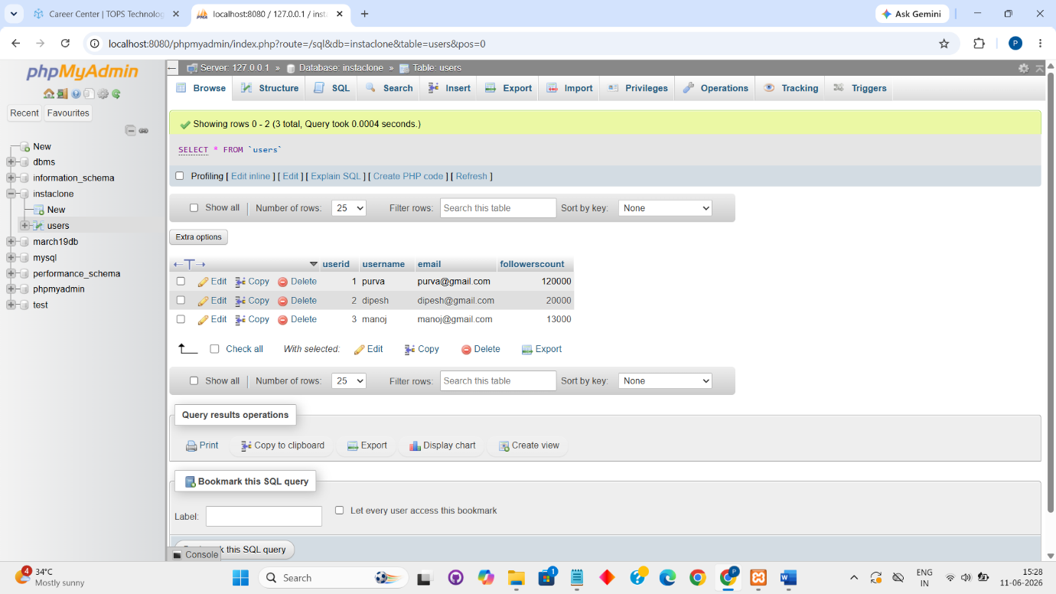

CREATE TABLE Posts (postid int AUTO_INCREMENT PRIMARY KEY,uid int,FOREIGN KEY(uid) REFERENCES users (userid),caption varchar(25),postdate date,);

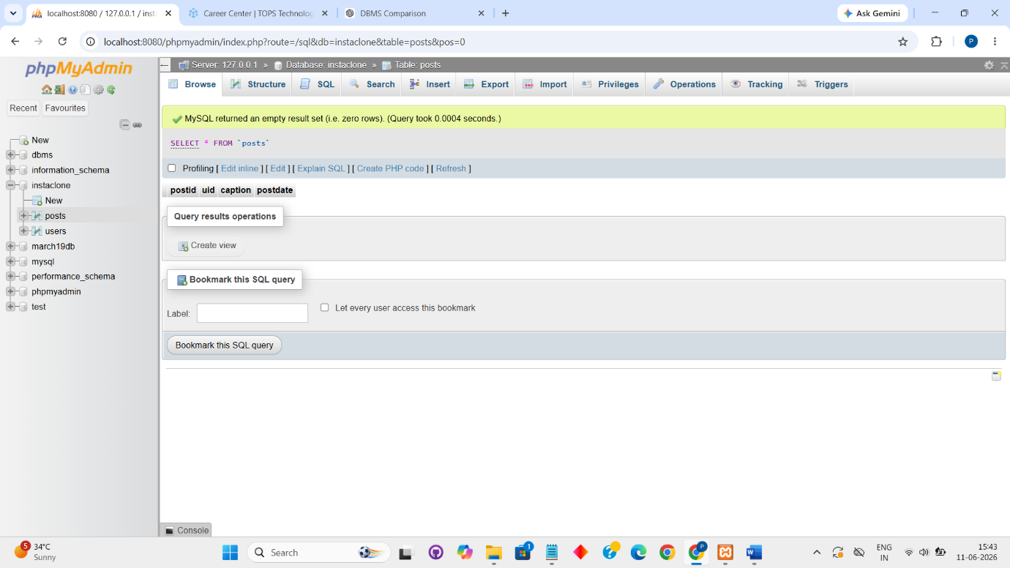

MySQL
MySQL is a popular open-source database mainly used in web applications and websites. It is commonly used with PHP, Laravel, WordPress, and e-commerce platforms. It is known for its speed, simplicity, and ease of use.

PostgreSQL
PostgreSQL is an advanced open-source database used for large-scale web applications, data analytics, and business systems. It offers powerful features, strong data integrity, and support for complex queries. It is popular among developers building enterprise-grade applications.

Oracle
Oracle Corporation Database is widely used in large enterprise systems such as banking, government, healthcare, and multinational corporations. It provides high security, reliability, and scalability. It is best suited for mission-critical applications that handle huge amounts of data.

SQLite
SQLite is a lightweight, serverless database commonly used in mobile applications, embedded systems, and desktop software. It stores data in a single file and requires no separate database server. It is widely used in Android apps and small-scale applications.

